**Market Segmentation Analysis on Electric Vehicles in India**

*by*

Kondabathini Mouli

GitHub: <https://github.com/Kondabathinimouli/EV_Market_Analysis/upload/main>

**Introduction**

The Electric Vehicle (EV) market in India is undergoing significant transformation, driven by a combination of factors including increasing environmental awareness, government initiatives, and an evolving consumer demand for sustainable, cost-effective transportation solutions. As India grapples with growing concerns about air pollution, fuel dependency, and climate change, EVs have emerged as a promising alternative to conventional fossil fuel-based vehicles. The country's robust population, rapidly expanding urban centers, and changing consumer preferences further reinforce the potential for electric mobility to disrupt traditional transportation.

A pivotal driver in this shift is the Indian government's push for widespread EV adoption through schemes such as the Faster Adoption and Manufacturing of Hybrid and Electric Vehicles (FAME II). Under this initiative, the government aims to achieve a 30% EV penetration by 2030, with substantial investments in the EV infrastructure, subsidies, and incentives for manufacturers and consumers alike. This ambitious target presents an unparalleled growth opportunity for businesses and startups looking to enter the sector.

In this context, this report focuses on analyzing the EV market in India, with a particular emphasis on identifying strategic entry points for startups seeking to develop and launch electric vehicle products. The analysis employs a segmentation approach, breaking down the market into distinct categories based on geographic, demographic, and psychographic factors, which are crucial for understanding consumer behaviour and preferences. This segmentation helps identify the most promising market niches, enabling startups to tailor their products and marketing strategies for specific customer segments.

To support the analysis, the report leverages available datasets and current market trends, drawing insights from industry reports, consumer behavior studies, and government policies. By understanding these dynamics, the report outlines actionable recommendations for startups to enter the EV market successfully, focusing on strategies for customer targeting, product development, and building a competitive advantage in a rapidly evolving market.

Ultimately, the objective is to provide a roadmap for startups to capitalize on India's growing EV market, enabling them to navigate challenges, seize opportunities, and position themselves as leaders in the emerging electric mobility ecosystem.

**Market Overview**

The Indian EV market is categorized by an increasing shift toward sustainable mobility solutions. Recent trends indicate a compound annual growth rate (CAGR) of over 40%, driven by government policies, subsidies, and advancements in battery technology. Major categories within the EV market include two-wheelers, three-wheelers, and light motor vehicles, each serving distinct customer segments. Urbanization and rising environmental awareness have further catalyzed market adoption, with major metropolitan regions emerging as early adopters.

**Methods Used in Analysis**

To analyze the EV market, several machine learning techniques were applied to the datasets provided. The following methods were used:

**1. K-Means Clustering**

K-Means clustering was employed to segment the geographic data by state based on the number of operational charging stations, EV manufacturers, and market readiness. This technique helped identify clusters of states that are most suitable for early market entry.

**2. Time Series Analysis**

The EV sales data from 2015 to 2024 was analyzed using time series methods to identify growth patterns and predict future trends for two-wheelers, three-wheelers, and light motor vehicles.

**3. Demographic Analysis**

Demographic data, such as urban population density and average income levels, was analyzed to determine the target customer base. Statistical methods and data visualization were used to highlight key trends.

**4. Behavioural Insights**

Behavioural patterns were analyzed using psychographic segmentation. This included identifying customer preferences for eco-friendly vehicles, cost savings, and technological features like GPS tracking and app integration.

The results from these analyses informed the strategic recommendations outlined in this report.

**Geographic Analysis**

**Key Locations for Early Market Adoption**

The geographic analysis identifies Maharashtra, Karnataka, and Delhi as the most promising regions for early market penetration. These regions were selected based on infrastructure availability, market readiness, and state-level policies encouraging EV adoption:

1. **Maharashtra**:
   * Leading in infrastructure with 3,079 operational public charging stations.
   * Home to 15 EV manufacturers, making it a robust hub for production and adoption.
   * Major cities like Mumbai and Pune offer significant urban demand, coupled with supportive government incentives for EV buyers.
2. **Karnataka**:
   * Bengaluru, known as India’s Silicon Valley, exhibits a high propensity for EV adoption due to its tech-savvy population and heavy traffic congestion, creating a demand for efficient transport solutions.
   * Supportive state policies and investments in EV innovation zones further enhance market potential.
3. **Delhi**:
   * Dense urban market with 1,886 charging stations, and a high level of public awareness of air pollution issues.
   * Recent subsidies and tax benefits for EV purchases make it a lucrative market for two- and three-wheelers.

Below is a bar chart illustrating the number of operational public charging stations across key states:

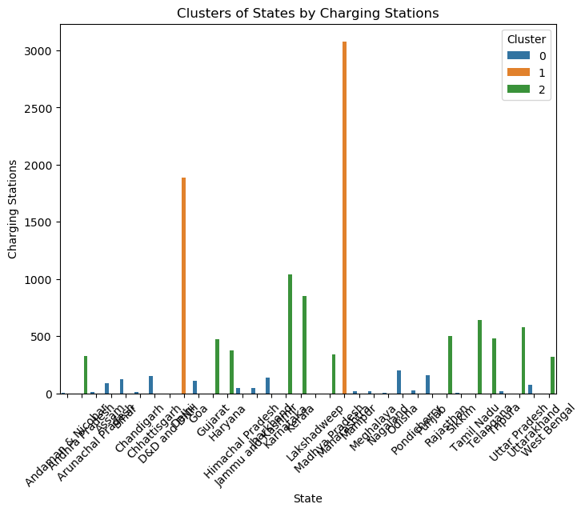

**Category Analysis**

**Trends in EV Sales**

An in-depth analysis of historical sales data (2015-2024) reveals the following trends:

* **Two-Wheelers (2W)**:
  + Dominate the market, with over 860,000 units sold in 2023 alone, accounting for the majority of EV sales.
  + Affordable pricing and ease of use make them ideal for urban commuters.
* **Three-Wheelers (3W)**:
  + Strong growth, particularly for commercial use in last-mile delivery and ride-sharing services.
  + Government subsidies for fleet operators have accelerated adoption.
* **Light Motor Vehicles (LMV)**:
  + Emerging as a niche market, especially among eco-conscious urban families.
  + Adoption driven by improvements in battery technology and range.

A pie chart below highlights the proportion of sales by vehicle category in 2023:

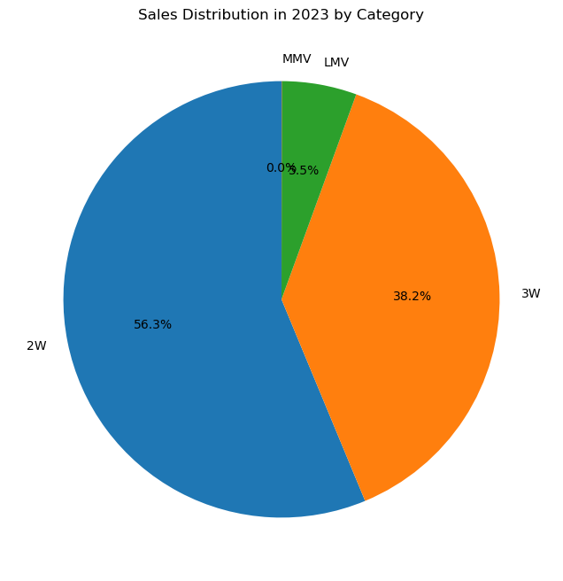

**Demographic and Psychographic Targeting**

**Key Customer Segments**

The EV market's customer base can be segmented into the following categories, based on their unique needs and preferences:

1. **Urban Commuters**:
   * Young professionals and students in metropolitan areas like Bengaluru, Delhi, and Mumbai.
   * High demand for cost-effective two-wheelers for daily commuting.
   * Attracted by low operating costs and eco-friendly features.
2. **Small Business Owners**:
   * Commercial operators using three-wheelers for goods transport and ride-sharing.
   * Prioritize low running costs, durability, and government incentives.
3. **Tech-Savvy and Eco-Conscious Consumers**:
   * Early adopters with disposable income and a preference for innovative, sustainable solutions.
   * Respond positively to features like smartphone integration, GPS tracking, and extended battery life.
4. **Fleet Operators**:
   * Companies managing logistics, food delivery, or ride-hailing services.
   * Seek scalability, reliability, and cost-efficiency in EV adoption.

**Behavioural and Psychographic Insights**

**Key Behavioural Patterns**

* Urban consumers value convenience, affordability, and government subsidies.
* Sustainability-conscious customers are drawn to environmental benefits and technological innovation.
* Businesses focus on operational cost savings and reliability.

**Psychographic Insights**

* Early adopters view EVs as a lifestyle choice, reflecting environmental responsibility and social status.
* Incentivizing customers through targeted campaigns about eco-impact and cost savings can enhance adoption rates.

**Implementation of Report**

1. **Data Consolidation**:
   * Collate datasets from government portals, market research reports, and industry publications.
   * Validate data accuracy and remove inconsistencies through data cleaning.
2. **Segmentation and Analysis**:
   * Apply statistical techniques to identify trends and customer segments.
   * Use visualization tools to present insights clearly.
3. **Strategic Recommendations**:
   * Develop region-specific marketing strategies targeting early adopters.
   * Collaborate with state governments and private enterprises to expand infrastructure and incentivize purchases.
4. **Execution Timeline**:
   * Short-term focus on high-potential regions (Maharashtra, Karnataka, Delhi).
   * Medium-term expansion to Tier-2 and Tier-3 cities with growing EV interest.

**Recommendations**

**Market Entry Focus**

1. **Target Geographies**:
   * Maharashtra, Karnataka, and Delhi for initial rollouts.
   * Develop localized marketing campaigns emphasizing cost savings and environmental benefits.
2. **Partnerships and Collaborations**:
   * Collaborate with state governments and private entities to expand charging infrastructure.
   * Partner with fleet operators and e-commerce companies for bulk sales and fleet solutions.
3. **Customer Engagement**:
   * Leverage digital platforms to engage tech-savvy customers.
   * Highlight testimonials, cost savings, and eco-benefits through case studies and real-life stories.
4. **Product Differentiation**:
   * Focus on range, charging speed, and smart features like app integration.
   * Tailor product features to specific customer needs, e.g., fleet solutions for businesses.

**Conclusion**

The Indian EV market presents a dynamic opportunity for startups to establish themselves by targeting the right segments with strategic products and pricing. By focusing on key geographies, leveraging demographic and psychographic insights, and adopting innovative approaches, the startup can position itself as a leader in this evolving market.

This report provides actionable recommendations and visual insights to guide market entry and growth strategies. Uploading the detailed findings and charts to GitHub will ensure accessibility and collaboration among team members.